Sebastian Oakes

Virtual Product Development 2017

Assignment

1. **Wheel Tread Profile - Design Considerations**

Railway wheel design is integral to the correct functioning of the locomotive under varying operational conditions, along with the safety and comfort of passengers.

The use of axially connected wheelsets within the locomotive industry has been a standard for over 200 years, and though specialist vehicles with separate wheel axes do exist, the tried and tested fixed wheel sets remain the norm. The combination of an angled tread with a fixed connecting axle provides stability on both straight and curve tracks. On straight sections of track, the effective change in wheel diameter causes braking on one side, steering the bogie back towards the centre of the track. This effective change in diameter also allows for the running of the wheelset along curved sections of track, for which differing wheel diameters are required to allow smooth running, and prevents reliance on the wheel flange to avoid derailment.

The exact profile of the wheel tread (and rail) therefore greatly influences the running characteristics of the vehicle. The aforementioned correction due to the angled tread forms a lateral oscillatory motion (commonly known as hunting oscillation), a cause of great instability at high speeds. For this reason, the tread profile must be carefully designed to fit the specific demands of the vehicle, be it for low speed heavy goods transport, extreme high-speed passenger transport (e.g bullet train), or anything in between.

Many running characteristics must be accounted for when designing a wheel; inherent stability, vibration resistance, rail and wheel wear, safety and curve negotiation are all particularly sensitive to variations in the wheel profile, and difficulty often arises in balancing these factors *[1]*. It is also of note that wearing of the wheel tread can therefore significantly alter the running characteristics, often requiring corrections to be made periodically through reprofiling of the wheels, and though a new design may appear to effectively reduce negative running characteristics, a high rate of wear will rapidly begin to negate this effect, as well as incurring obvious economic costs.

The advent of CAD and FEA has therefore provided an effective method for optimising the wheel and rail profiles, and testing their characteristics without the temporal and monetary costs associated with repeatedly producing physical prototypes. The virtual environment therefore proves to be particularly useful in the development of rolling stock, and for consideration of the full lifecycle of the product.

B-splines have been used extensively in the design and optimization of wheel profiles. Work by X.Liu et al. utilized NURBS in the optimization of the rail profile, with focus on matching the profile of the rail (since the rail is far more expensive to produce/replace). The stability region curve was designed to give an optimal curve of rolling radii difference against wheelset lateral displacement. [2]

A similar method was proposed by I.Y.Shevstov et al. for the optimization of tram wheels, again to match a target rolling radii difference function, this time using a numerical optimisation method to vary control points in a B-spline [3].

V.K. Goel et al. utilised b-splines in the modelling of wear on various tread profiles [4].

The profiles tested were iteratively modified depending on the distribution of contact points across all between rail and wheel configurations, in order to model the likely wear characteristics of the rail profile without testing on physical models.

1. **CAD Design of Wheel and Rail Profiles**

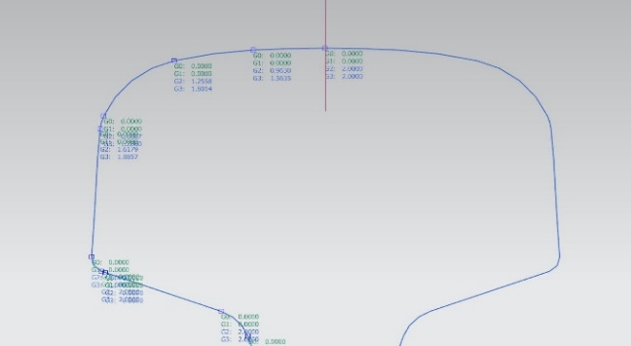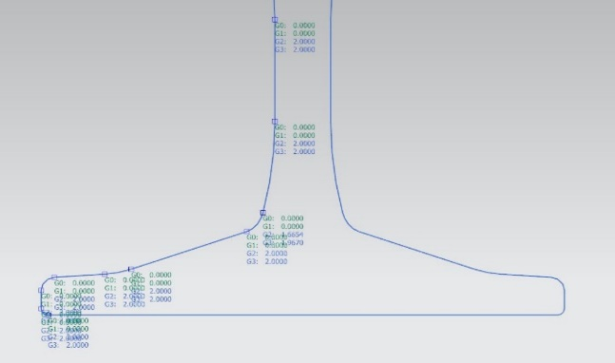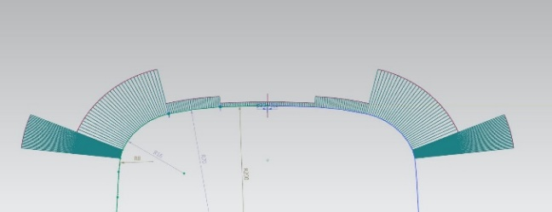

Figure 2 - Demonstration of continuity and curvature for rail profile

Rail Profile

The profile of the rail was designed according the UIC-60 specification, the standard for British railways, according to the diagram in figure 1. The accuracy of this model forms an integral part of later FEA, since the rail provides a control variable, against which various wheel profiles can be tested.

The diagram itself was overlaid to provide a basis upon which to build the profile, with basic points placed to ensure the correct proportions were achieved. Height measurements given by the diagram ensured that straight, sloped surfaces on the base and head could be given the correct gradient.

Once these initial geometric reference lines were placed, the profile could be built according to the information contained in the diagram, built entirely using radial and straight lines, with fillets used at intersections between straight edges. This made it particularly simple to ensure the profile design accurately matched the UIC-60 specifications.

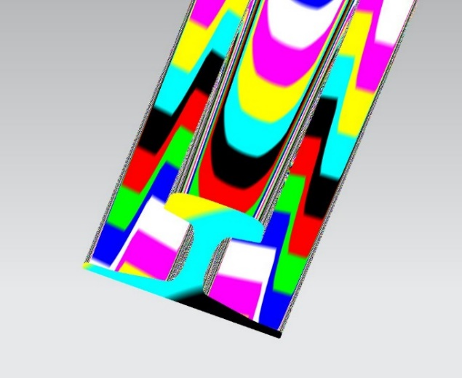

Figure 3 - Surface analysis of final extruded profile

Figure 2 demonstrates that G1 continuity conditions are met along the entire profile, as well as displaying a curvature analysis of the top surface of the rail, with the uniform curvature of each profile segment shown clearly.

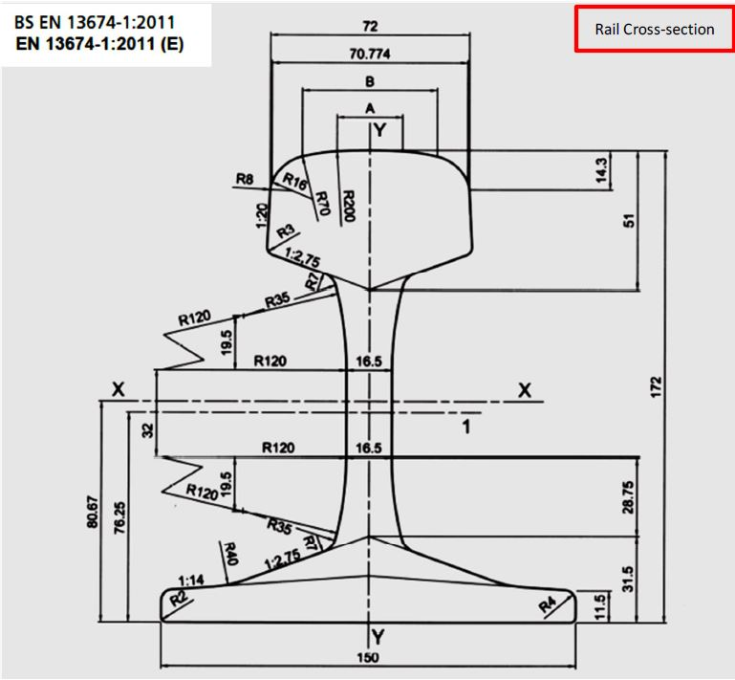

Figure 1 - UIC-60 rail profile

Only a single side of the profile was built, before being mirrored across a plane, and the two resulting sets of curves being joined. Curve continuity was again tested across the join to ensure that the full profile had formed correctly. The profile was then extruded to form the final 3D model of the rail used for later FEA. The surface analysis in figure 3 demonstrates the lack of any unwanted surface artefacts, with a smooth transition between the joined curve sets.

Wheel Profile

The general wheel profile chosen was the ‘450 Wheel’, manufactured by *Jiangsu Railteco Equipment Co.* This profile fit the required dimensions, as well as being of the straight-webbed, monobloc form. The manufacturers engineering drawing is displayed in figure 4, and provided the main reference material.

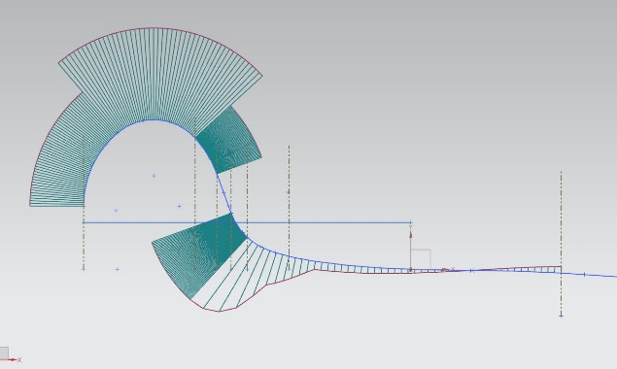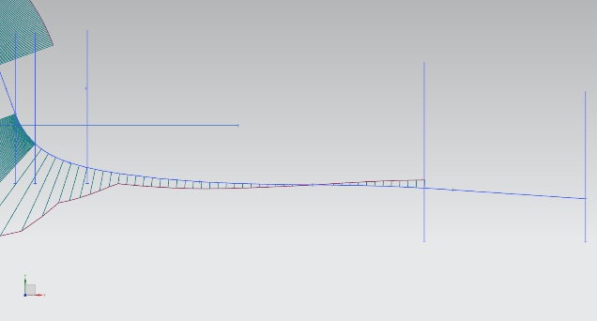

Figure 5 - Curve analysis of the flange and tread before optimisation, with close-up of stability region.

Once a wheel profile had been selected, the profile could be built using similar methods to the rail, with the exception of the wheel-rail contact surface, which was designed according the UIC-510 specifications specific to the wheel size. Most of the wheel could be built through simple reference to the dimensions and geometry taken from the engineering drawing; most of the wheel profile consisted of straight edges with filleted corners, and was trivial to design in NX.

The profile of the flange and tread was designed according to the strict specifications laid out by the International Union of Railways. The sets of equations for linear, quadratic and higher order curves (describing zones A-H in the flange/tread profile) were input into the OriginLab data analysis software, allowing y values to be attained from imputed x values. The x values of each zone boundary were taken from the UIC-510 specifications, with further points added within zones to aid in spline generation. These (x,y) coordinates were then imported into the NX software, to be used as spline control points.

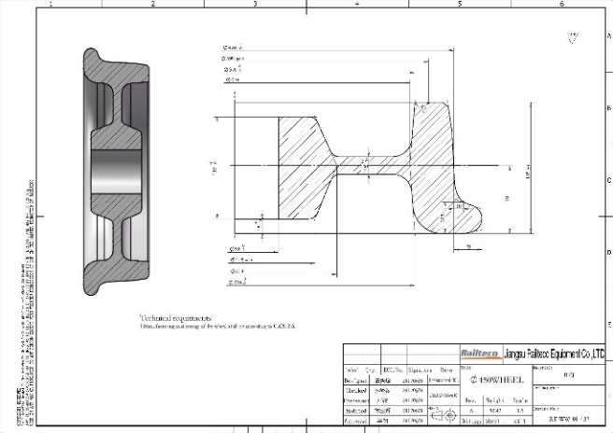

Figure 4 - Engineering drawing of chosen wheel profile, from manufacturer Jiangsu RailTeco

Various zones could be accurately represented as arcs or lines (A, D, E, F, G, H), while higher order curves across zones B and C were connected using a B-spline. As with the rail profile, curve continuity was ensured along all transitions between arcs, curves and splines.

The B spline used through zones B and C was initially passed directly through the given data points, coinciding with the edge of section A with G2 continuity. The resulting profile, compared against the UIC standard, is displayed in figure 6.

A straightforward revolve was then utilised to create the full 3D wheel. Care was taken to ensure that a sufficient degree of tolerance was used for the revolve; it was quickly realised that the standard level of tolerance (0.1mm) led to a tread surface that was a poor representation of the profile used, with the previously curved edge now approximated using flat surfaces. Careful modelling of the tread profile would not count for much in later FEA analysis if the revolved wheel bore little resemblance to the initial design. This tolerance was increased to 0.00001mm, to ensure the wheel model was true to the developed tread profile. This process was repeated for the rail extrusion, for the same reasons.

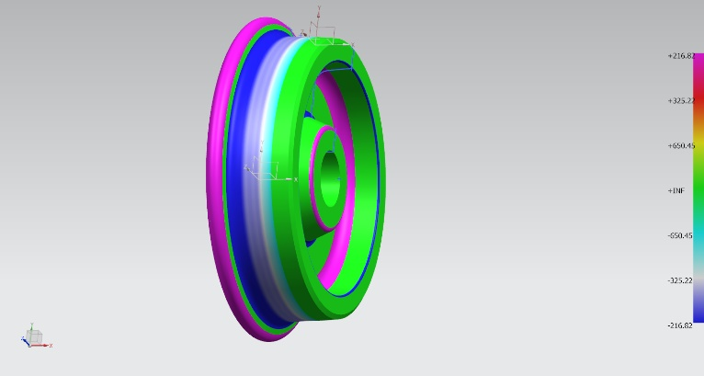

Figure 7 - Face curvature analysis of the finished wheel model.

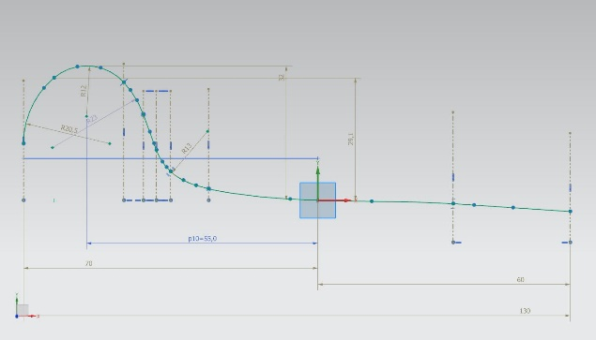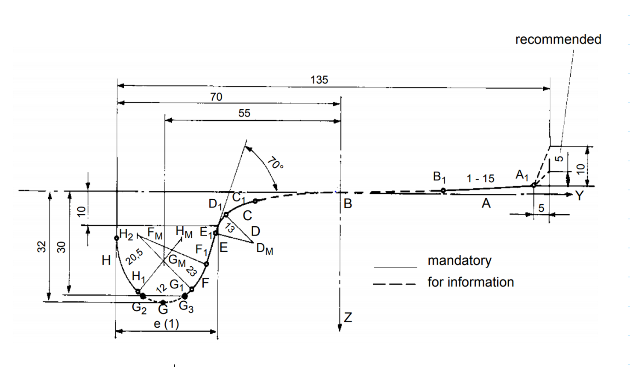

Figure 6 - Comparison of UIC specification against modelled tread profile, with critical proportions displayed.

1. **Optimisation**

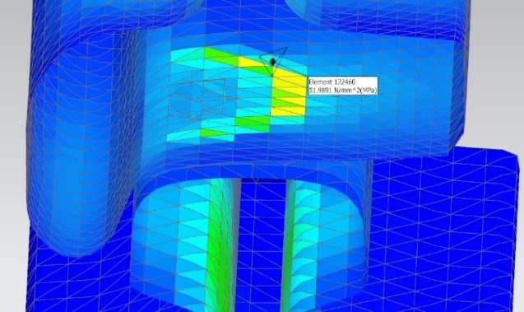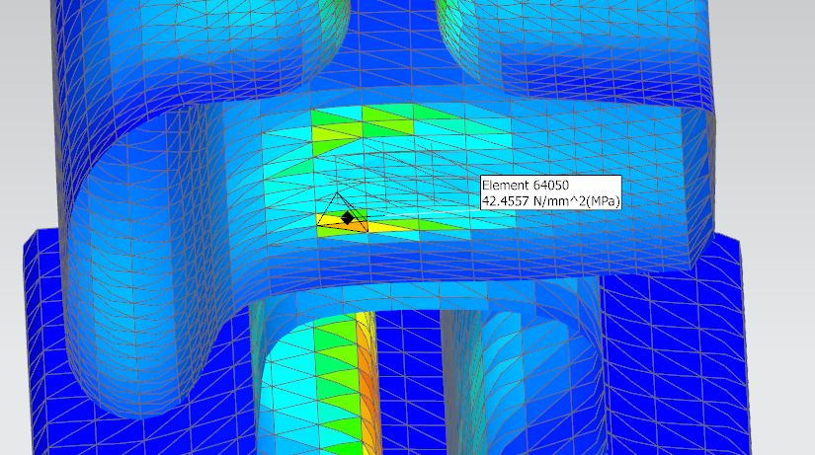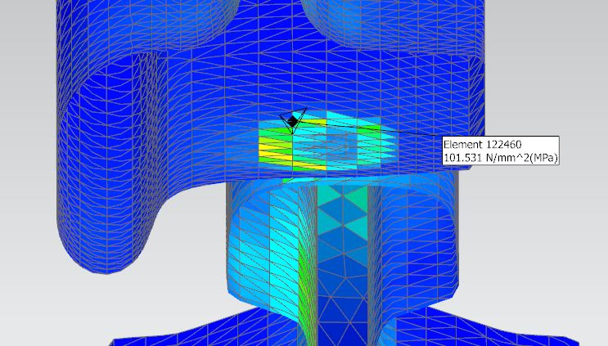

Figure 8 - FEA von Misen stress results before optimisation. View is of a section, with relative surface element stresses displayed visually.

The wearing characteristics of wheel treads has great impact on the regularity of necessary reprofiling, and thus it is the mitigation of uneven wear that formed the objective of subsequent optimization.

The stability region (region B in figure 6) of the wheel profile formed the focus of further optimization, and the wear of the rail surface is not considered here.

Finite Element Analysis

The previously modelled wheel and rail section were then subjected to FEA analysis within NX Nastran. The initial wheel profile was tested under three different static load conditions, each relating to a different placement of the wheel on the track, specifically within the stability region of the tread.

The simulations were performed as follows: rail and Wheel were brought into contact at the desired point, the lower surface of the rail was spatially constrained (mimicking the fixing of the rail to the sleepers) and a force placed vertically on the wheel, incident through the inside of the axle. The resulting images in figure(?) display the resulting stress analysis for each tread position, with points of highest von Mises stress highlighted for reference. Three simulations were carried out for each, representing pressure on the inside edge, middle and outside edge of the stability region of the tread due to the rail. For each simulation, a test force of 6250kgf was used, representative of the force incident on a single wheel when supporting 1/8th the weight of a typical passenger train carriage (approximately 50 tonnes). As a material, rolled steel was used; though this is not the typical material used in production of wheels or rails, the aim here is simply to compare stress distribution, and therefore chosen material is not a priority.

It is noted from the results of these simulations that stress dramatically increases near the outer edge of the stability region for this unoptimized profile. With reference to figure 5, it appears likely the inflection point is the cause of this large disparity; an inversion in curvature creates a ‘hump’ in the wheel profile, decreasing contact area and increasing pressure per unit area.

The presence of such stress disparities would likely pose issues over the lifecycle of the wheel. Greatly increased pressure on the inner portion of the stability region would cause uneven wear, for which more regular reprofiling would be required to ensure the running characteristics remain within acceptable tolerances.

Thermal loading is strongly attributed to crack formation and growth , and repair in such scenarios is particularly difficult. [6] The highly uneven pressure distribution across this unoptimised tread profile would likely cause excessive localised heating (particularly under braking load), and therefore act as a potential source of tread damage, and even catastrophic failure.

**Further Iterations**

The wheel profile was then modified with the intention of reducing the stress across the whole profile, with particular emphasis on the removal of the aforementioned high stress point on the inside edge.

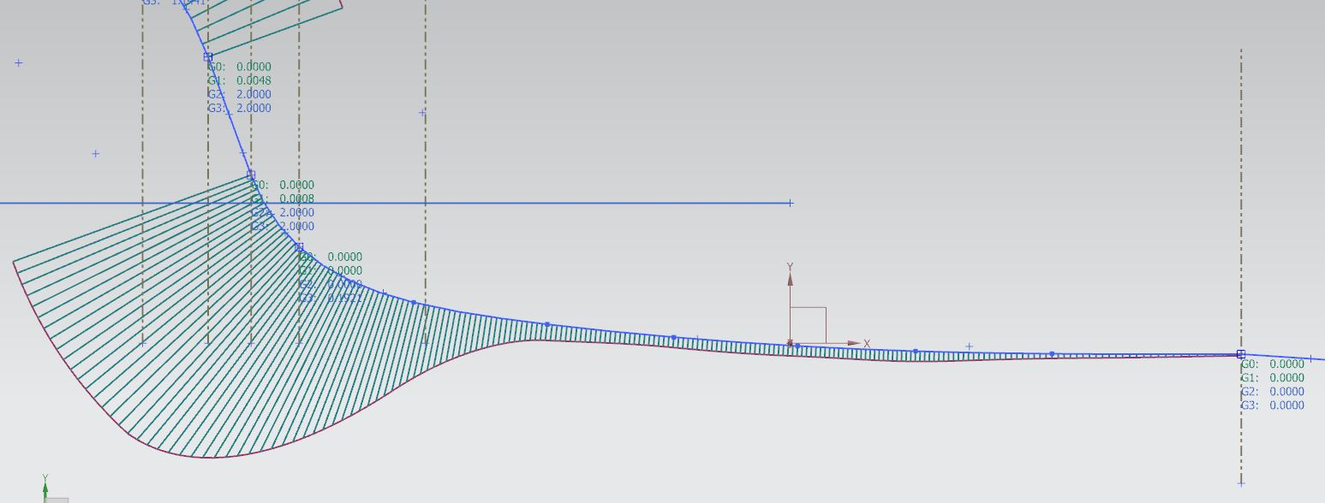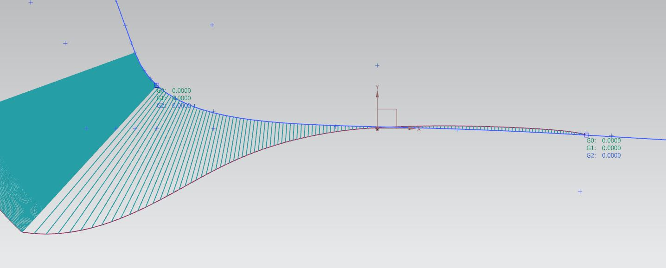

Figure 9 - Two new profiles considered for the stability region.

Two further designs were considered, as displayed in figure 9. The first design completely removed the inflection point in the stability region, with the aim of alleviating problem of high pressure towards the inside of the stability region. The removal of this inflection point also flattened out the profile, creating an even distribution of pressure across the region, when placed under static load. This was necessary in order to remove the inflection point whilst still retaining the general characteristics of the wheel profile.

The flattening of the tread causes this wheel to more closely resemble those used on high speed rail networks; the instability caused by hunting oscillation becomes particularly prominent at high speed, and thus wheels with a reduced conicity are required [6]

This first profile, though performing well (and as expected) under early FEA, held flaws that caused it to be discarded. The transition point between zones A and B was a cause for concern; to ensure that the inflection point in zone B was eliminated, the change in curvature at the transition point was particularly pronounced. This would likely cause extensive instability issues as the rail-wheel contact point transitions across these two zones, whilst causing excessive wear for the rail.

The second profile provided a more subtle change. For the tread profile to remain smooth, the inflection point was considered a necessary feature. Therefore, focus shifted to reducing the impact of the inflection point on the stress characteristics of the wheel under load.

The profile used for the first iteration was smoothed to form a more fluid tread profile, whilst simultaneously extending the inflection point to create a less pronounced transition between positive and negative curvature.

Results for this profile were somewhat promising when considering the optimization aim. Figure 10 displays FEA results for this profile, with a reduction in von Misen stress at the three points analysed (the same points used for FEA in the first iteration). The extension of the positive to negative curvature transition has reduced the stress on the inside edge of the stability region as was desired, as well as reducing stress across the midsection.

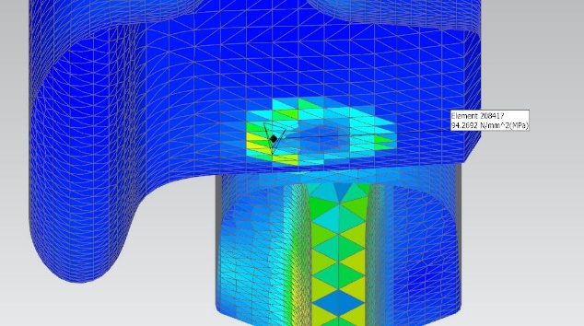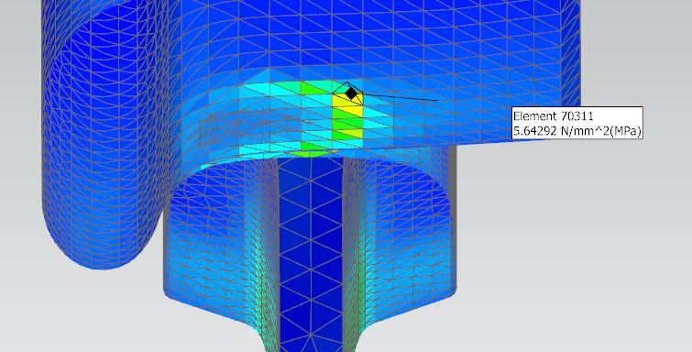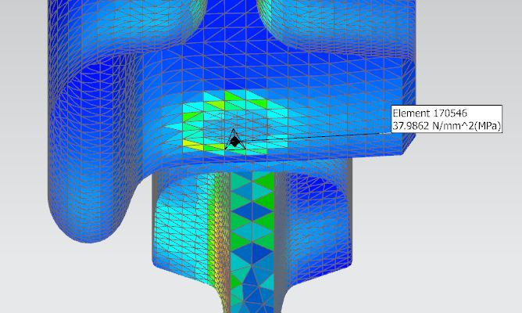

Figure 10 – Von misen stress analysis for the tread/rail configurations used previously, with optimised wheel profile.

A more surprising result was the significant reduction in stress on the inside edge, which dramatically decreased. This simulation was repeated to ensure an error had not been made, but this yielded similar results. It is suggested that this results from a higher degree of conformity between the rail and wheel profiles, thereby spreading the load more evenly, and reducing pressure per unit area.

A few repercussions of this were considered. Firstly, this increased conformity would drastically affect the contact profile; most rail wheels are designed to fit the rail with one or two contact points (usually two for the inside edge of freight wheels). Single-contact profiles are elliptical in shape, and the size dependent on the wheel diameter and conformity. Since rail wheels are designed with minimal friction in mind, a smaller contact profile is considered optimal under most circumstances. This particular profile, with its high conformity to the rail, would lengthen the contact ellipse, therefore increasing overall frictional forces when the wheel and rail are in this configuration. This is therefore a concern regarding efficiency, due to energy losses.

Stability in this consideration was also of concern, though existing research into the effects of conformity on stability at a range of speeds would suggest that stability is largely unaffected by conformity. [5]

Accuracy of the FEA model

Difficulty arises in using FEA analysis in this role; the results are based on a model of the real-world system, and thus the quality of the model has a large impact on the quality of results. For the simulations carried out, a balance needed to be found between the density of the mesh (and therefore the accuracy with which it represents the wheel profile), and the time taken for computation. Beyond the mesh size used here, computation of results was particularly slow, and prone to crashing. It is suggested that any future FEA should consider a variable mesh size, with a closer spacing of mesh elements near the contact point to reduce computational strain. Failing this, improving computing resources could alleviate this issue.

This FEA model is particularly limited in its consideration of the factors affecting wheel performance characteristics, with only stress under static load considered. Extension to consider thermal loading could shed light on the distribution of heating across the wheel, particularly under braking load. This would be required to completely rule out the possibility of heat related issues.

Vibration and noise is also a common issue in rolling stock; modern passenger transport has the ride comfort to consider, and resonance in any engineering application can cause catastrophic failure under the certain circumstances. An improved (or extended) FEA model could therefore include consideration of the frictional forces at play, and the resulting vibration. This is not a trivial task, due to the huge number of variables involved: track condition, environmental conditions, running speed, wheel material and wheel and rail configuration.

Bibliography

[1] J. Santamaria, J. Herreros, E. G. Vadillo & N. Correa, Design of an optimised wheel profile for rail vehicles operating on two-track gauges, Vehicle System Dynamics Vol. 51, Iss. 1, 2013

[2] Y. Liu and X. Liu, Railway Wheel Profile Optimization Design Based on Nurbs Curve, *2010* Second International Conference on Computer Modelling and Simulation, Sanya, Hainan, 2010, pp. 331-335.

[3] I.Y. Shevtsov, V.L. Markine, C. Esveld, Optimal design of wheel profile for railway vehicles, Wear, Volume 258, Issues 7–8, 2005, Pages 1022-1030,

[4] V. K. Goel, V. H. Saran, R.Patil, optimization and wear determination of rail wheel profile for indian railway specifications, international journal of mechanical engineering and technology (ijmet) volume 7, issue 5, september–october 2016, pp.86–96

[5] Eric E. Magel, Yan Liu, On some aspects of the wheel/rail interaction, Wear, Volume 314, Issues 1–2, 2014, Pages 132-139,

[6] D. Peng, R. Jones, and T. Constable, A Study into Crack Growth in a Railway Wheel Under Thermal Stop Brake Loading Spectrum, *Eng. Fail. Anal.*, vol. 25, pp. 280–290, 2012.

[7] D. Baldovin , S. Baldovin, The influence of the wheel conicity on the hunting motion critical speed of the high speed railway wheelset with elastic joints, Rev Rom Sci Tech-Mec, 2011